***Abstract***

***Most job platforms do not consider neurodivergent users, making it difficult for them to navigate their careers online. Complicated layouts, dense text, and vague instructions often lead to confusion and anxiety. Traditional hiring systems unintentionally exclude many talented individuals. To tackle these challenges, our platform offers real-time guidance, mental support, and easier-to-understand content. It employs the Supabase Table Algorithm (PostgreSQL) for quick data storage and retrieval of quizzes and user information, ensuring smooth performance. The Edge Function with GPT-4 Algorithm (OpenAI API) creates adaptive quizzes and personalised content based on each user’s skills and learning history. The Text Match Algorithm (Supabase Edge Function) checks for plagiarism by measuring user submissions against stored data. Through gamified quizzes, responsive feedback, and tailored recommendations, the system enhances accessibility, engagement, and job matching. This approach helps neurodivergent users showcase their skills with confidence and fosters a more inclusive digital workspace.***

***Keywords: Neurodivergent users, GPT-4, plagiarism detection, real-time assistance, skill assessment.***

**I. INTRODUCTION**

Technology has become a central component of modern education, employment, and personal development. However, most digital platforms operate under a "one-size-fits-all" assumption, overlooking the diverse ways neurodivergent individuals, including those with autism, ADHD, or dyslexia, learn and interact. This oversight creates significant barriers, as complex layouts, overwhelming information, and a lack of tailored support can hinder their access to opportunities and lead to unequal participation in both learning and career development [1, 3].

Existing research has highlighted these challenges and the need for inclusive practices. For instance, studies have shown that technology-based accommodations are valued by autistic employees, and that designing workplace systems around the strengths of neurodivergent individuals is critical [1,3]. Moreover, research indicates that neurodivergent professionals may feel pressured to hide their struggles, even in supposedly inclusive teams [2]. While advancements in job recommendation systems have improved personalisation, these systems rarely focus on deeper issues of accessibility or inclusivity for neurodivergent populations [4].

Despite these insights, a significant gap persists: mainstream career platforms are not fundamentally designed to support neurodivergent users. Few offer specialised features such as gamified skill assessments, targeted mental health support, or mechanisms to provide actionable feedback for employers to improve inclusivity.

To address this, our project introduces neurobridge, a platform that combines these crucial features while also providing feedback to mainstream platforms. By empowering neurodivergent individuals to confidently pursue career opportunities and by helping organisations adopt inclusive practices, Neurobridge aims to bridge the current systemic gaps.

**II. LITERATURE REVIEW**

The study of neurodiversity in the workplace has become increasingly significant due to the persistent challenges neurodivergent individuals face in accessing meaningful employment and participating fully in professional environments. Individuals with autism, ADHD, and dyslexia often encounter barriers when navigating conventional online job platforms and organisational systems. These challenges frequently stem from design assumptions for neurotypical users rather than inherent deficits of neurodivergent individuals. Addressing these obstacles through inclusive technological solutions is essential to reducing unemployment, which remains high at approximately 30–40% and to leveraging the unique cognitive strengths this population offers. Neurobridge represents a real-time interactive platform that assesses skills, identifies difficulties, and provides actionable recommendations to improve inclusivity in mainstream employment platforms [1,13,14].

Research highlights the critical role of technology in supporting neurodivergent employees. Studies show that autistic employees’ preferences for technology-based workplace accommodations significantly impact participation and productivity, underscoring the importance of accessible, personalised interfaces [1,15]. Similarly, pressures to conform to neurotypical norms negatively affect performance, engagement, and well-being in software development teams, illustrating the need for supportive interventions [2,16]. While these works offer valuable insights, they often lack operational, real-time systems for skill assessment or adaptive platform functionality.

Designing for individual strengths rather than deficits is emphasised across multiple studies, aligning with Neurobridge’s objectives of skill-based assessments and personalised recommendations [3,18]. Approaches such as hybrid information filtering engines improve job recommendation relevance but rarely address neurodivergent accessibility, interface design, or real-time adaptability, limiting their effectiveness for inclusive platforms [4,17]. Collaborative, user-centred design frameworks highlight that involving users in design enhances usability and satisfaction; however, these frameworks remain largely conceptual without operational systems capable of identifying barriers and offering actionable guidance [5,7,20,21].

Human-in-the-loop AI systems illustrate that continuous feedback enhances engagement, personalisation, and user satisfaction, principles directly applied in Neurobridge’s adaptive design [6,11,17,22]. Other studies consistently document persistent challenges for neurodivergent individuals, including low personalisation, limited accessibility, insufficient mental health support, and inadequate attention to cognitive or sensory needs [8–10,12,19]. Assistive technologies, emotion recognition tools, and AI-driven interventions have demonstrated potential in facilitating skill development, workplace accommodation, and early detection of support needs [23–27].

By integrating these insights, Neurobridge addresses both conceptual and practical gaps. Combining AI-driven intelligence, adaptive learning algorithms, human-centred design, and real-time interaction, the platform empowers neurodivergent individuals while providing actionable recommendations for mainstream employment systems. This approach moves beyond descriptive research, delivering a scalable and operational solution that enhances accessibility, inclusion, and equitable workforce participation [1–27].

**III. METHODOLOGY**

Neurobridge is a real-time, inclusive platform created to support neurodivergent users in skill assessments, task completion, and finding suitable opportunities. (Figure 1)The system starts by connecting with schools, NGOs, and therapy partners to provide an interactive portal for evaluating digital skills, attention levels, and comfort with tasks. Tasks and quizzes dynamically adjust based on individual performance to ensure appropriate challenge while keeping users motivated through gamified experiences. Real-time functionality is driven by the Supabase Table algorithm, which manages the storage and retrieval of quiz questions and user responses, enabling smooth, instant interactions. Quiz content and feedback are generated dynamically using the Edge Function with GPT-4 algorithm, allowing personalisation of tasks according to skill levels and progress. The Text Match algorithm within the Supabase Edge Function checks for similarity and plagiarism in responses, while a local evaluation algorithm assesses performance and delivers immediate scoring and feedback. The system continuously collects behavioural and interaction data to identify usability and accessibility issues. Insights from this data are shared with platforms and employers to enhance navigation, interface design, and overall accessibility, fostering more inclusive digital environments. The combination of real-time algorithms, adaptive task management, and user-focused design creates a supportive platform that connects neurodivergent talent with inclusive opportunities.

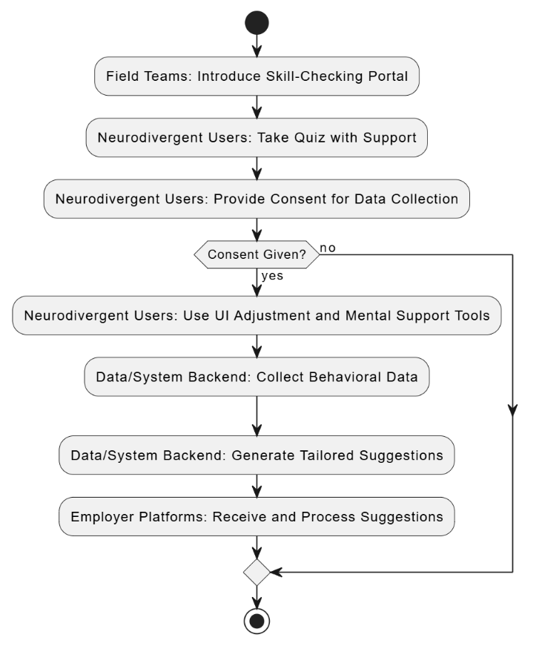

**Figure 1. Flow Chart**

**A. System analysis and requirements**

The development of neurobridge began with a thorough requirement-gathering phase that involved interviews and discussions with neurodivergent individuals, educators, therapists, and partner organisations. These discussions revealed major issues with existing career platforms, such as confusing layouts, limited customisation, and poor mental health support, which all create obstacles to navigation and engagement. Based on these insights, the platform was designed to provide users with a personalised dashboard to manage their profiles and track their progress. It features gamified quizzes across areas like programming, problem-solving, and web development, allowing users to assess and show their skills. Quiz results and profile data automatically create professional resumes to help candidates highlight their strengths. A managerial dashboard was developed for employers or supervisors to monitor multiple candidates, filter by skills and test scores, and generate reports. Beyond these functional specifications, accessibility, security, and scalability were prioritised. The platform incorporates dyslexia-friendly fonts, a calm-mode interface, text-to-speech, and voice input to create an inclusive and comfortable experience. User data is securely stored and managed to protect privacy, while the system is designed to scale effectively, supporting many users at the same time without conflicts.

**B. System Architecture**

The neurobridge platform has a modular and scalable structure that supports both neurodivergent candidates and supervising managers, ensuring smooth and reliable operation. At the core (Figure 2)is the Candidate Module, which offers an intuitive and supportive interface. Candidates can securely manage their profiles, take part in gamified skill assessments, track their progress with visual dashboards, and automatically create professional resumes. This module emphasises accessibility, featuring options like dyslexia-friendly fonts, a calm-mode interface, text-to-speech, and voice input, making it especially suited for neurodivergent users.

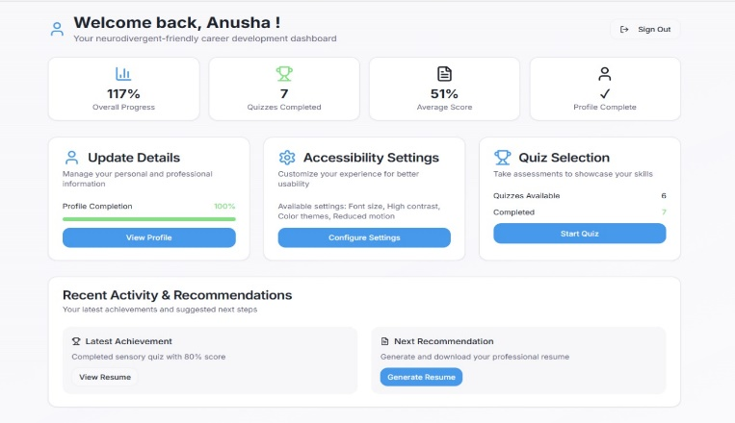

**Figure 2. Candidate Module**

The Manager Module (Figure 3) facilitates easier management and understanding of candidate information for HR professionals and supervisors. It brings all important details, such as skills, experience, and quiz results, into one clear and organised dashboard. Managers can easily track each candidate’s progress, see how they perform over time, and identify areas where they might need support or training.

The module also lets users filter candidates based on their skills or test results, helping managers quickly find the right person for a specific role. With its report generation feature, managers can create detailed summaries and share them with their teams to support better hiring decisions.

Overall, this module not only simplifies the recruitment process but also promotes fairness and inclusion. By giving managers helpful insights and tools, it ensures that every candidate is evaluated thoughtfully and that hiring decisions are both efficient and equitable.

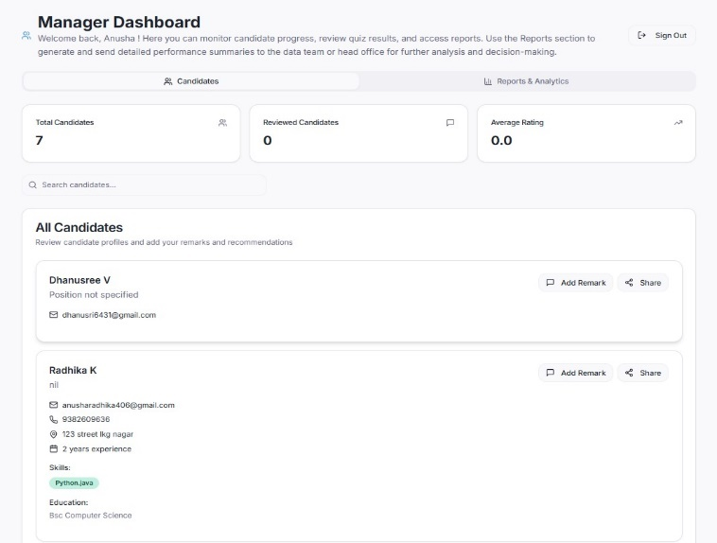

**Figure 3. Manager Module**

Supporting these modules is a strong backend powered by Supabase, which securely manages all data operations, storing sensitive user records and quiz results while ensuring privacy compliance. The backend communicates effortlessly with the frontend built in React, TypeScript, and Shadcn UI, guaranteeing consistent interactions. Tailwind CSS and PostCSS provide styling and accessibility, creating an appealing and customizable interface.

Accessibility settings(Figure 4) help users personalise their experience for better comfort and usability. In the Visual Preferences section, users can turn on High Contrast Mode for clearer text and visuals, reduce motion to avoid distractions, change the Font Size for easier reading, and switch colour themes based on their preference. The Audio Preferences let users enable Sound Feedback to hear audio cues when they interact with different elements. Under Navigation Preferences, the Enhanced Keyboard Navigation feature allows smoother movement between sections using keyboard shortcuts. The Accessibility Tips & Shortcuts section provides guidance on using keyboard navigation and assistive tools like screen readers. Overall, these features are designed to create a more inclusive and user-friendly environment, especially for neurodivergent users, making it easier for everyone to interact comfortably and confidently within the neurobridge platform.

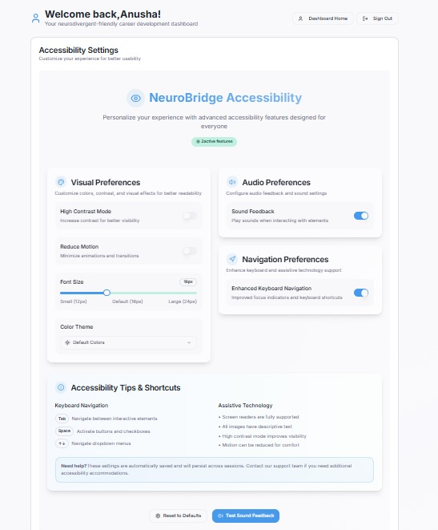

**Figure 4. Consistent Interactions**

The platform features a flexible API layer, allowing future integration with external systems like LinkedIn or Unstop, letting Neurobridge continue to evolve to meet the needs of users and organisations. This architecture ensures that both candidates and managers experience a smooth, inclusive, and efficient workflow while remaining scalable for many concurrent users. Interaction begins when a candidate logs into the system with their email and sets up their profile by entering personal details, skills, and accessibility preferences. After completing the profile, the candidate takes a quiz to gauge their abilities. The system provides feedback, allows them to update their resume, and displays a progress map highlighting their strengths and areas for improvement. Meanwhile, the manager uses the dashboard to view candidates, filter them by skills, and generate reports based on quiz results and progress data. This setup allows candidates to see their growth clearly, while managers gain insights to better understand and support each candidate.

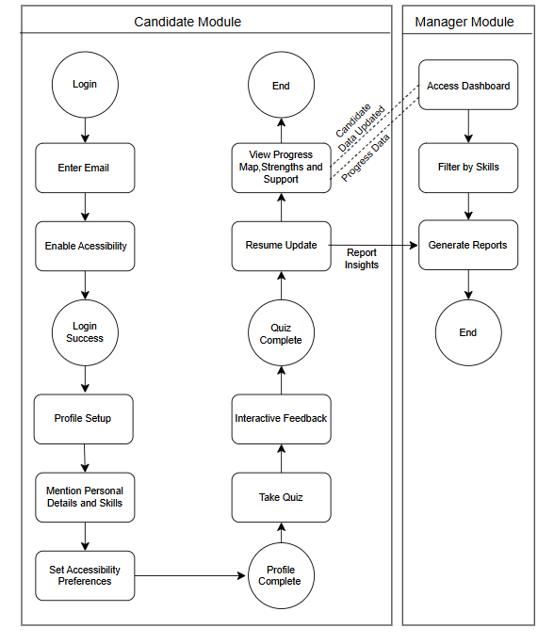

**Figure 5. Interaction**

**C.** **Data Collection**

To evaluate the neurobridge platform, data were systematically gathered to assess both usability and effectiveness in assisting neurodivergent individuals. Participants included neurodivergent individuals from different backgrounds, such as those with ADHD, ASD, dyslexia, sensory processing differences, and coordination issues. To get a thorough understanding of user needs, participants were engaged through partnerships with schools, therapists, and NGOs, ensuring all data collection adhered to privacy and ethical protocols. The platform used Supabase (Figure 6)as the primary tool for data collection and storage, enabling secure, real-time capture of participant interactions while maintaining multi-session support and scalability. This included recording quiz responses, progress tracking, skill assessment results, and user preferences for accessibility features. Additionally, behavioural data such as time spent on quizzes, number of attempts, and adjustments in difficulty were recorded, providing valuable insights into user engagement and areas needing more support.

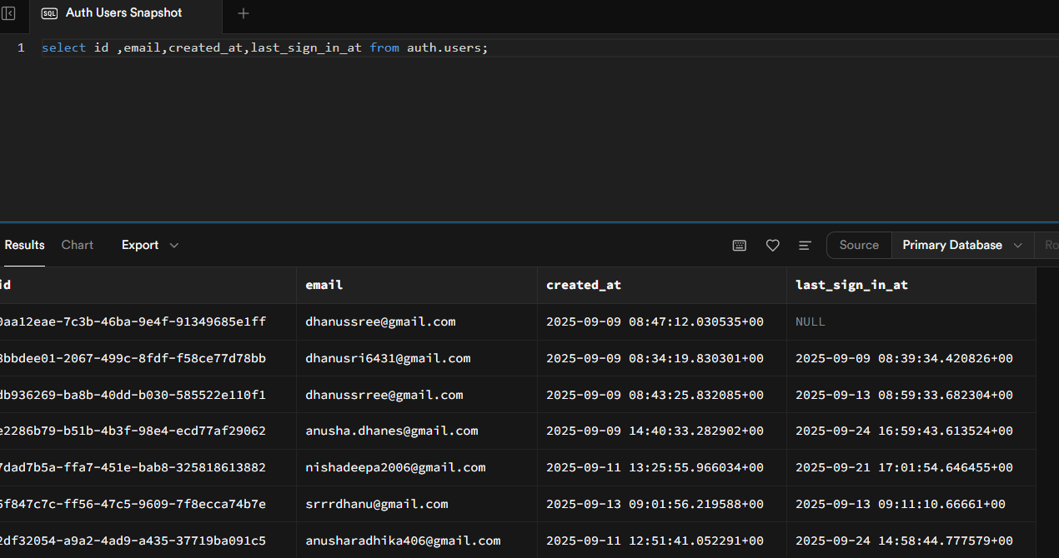

**Figure 6. Multi-session Support**

The data collection process followed a structured approach. Participants logged into the platform and chose their neurodivergent type. They then engaged with gamified quizzes designed to assess their cognitive, technical, and problem-solving skills. All responses and interactions were secured by the Supabase backend, which enabled real-time synchronisation and ensured that each participant's data was safely stored in their unique profile. Feedback from participants about the interface, accessibility, and overall experience was collected through in-platform surveys and behavioural metrics, providing both quantitative and qualitative insights. This data collection strategy allowed the neurobridge team to analyse skill proficiency, engagement trends, and accessibility needs, leading to continuous improvements to the platform while ensuring the experience remained supportive and individualised.

**IV** **MATHEMATICAL AND DATA ANALYSIS**

**A. Real-Time Quiz Data Storage and Retrieval (Supabase Table)**  
Let $Q$ represent the set of quiz questions and $U$ the set of users.

Querying user data:

$$Q_{u}=\{q∈Q:q.user=u\}$$

where $Q_{u}$ is the set of quiz questions assigned to user $u$. For $N$ concurrent users and average query time $t_{q}$:

$$T_{read}=N⋅t_{q}$$

Assuming constant query performance with indexing.

**B. Edge Function with GPT-4: Quiz Auto-generation**  
Given a user’s skill vector $S_{u}$ and history $H_{u}$, the algorithm generates a quiz set:

$$Q_{u}^{'}=GPT4(S_{u},H_{u})$$

where $Q_{u}^{'}$ is tailored to $u$'s needs. Let $T_{gen}$ be the average generation time per quiz:

$$Q_{u}^{'}=arg⁡\underset{Q^{'}∈Q}{max⁡}relevance(Q^{'},S_{u},H_{u})$$**C. Text Matching for Plagiarism Detection**  
Given a new submission $T$ and a database of previous answers $D=\{d_{1},d_{2},...,d_{k}\}$:

Cosine similarity score:

$$Sim(T,d)=\frac{T⋅d}{∥T∥∥d∥}$$

Plagiarism is detected if:

$$\underset{d∈D}{max⁡}Sim(T,d)>θ$$

where $θ$ is the similarity threshold.

**D. Scoring and Feedback (Local Evaluation)**  
Let $A$ be user answers and $K$ be correct answers. For each question $i$:

$$Score_{i}=\{\begin{matrix}1, & \text{if }A_{i}=K_{i} \\ 0, & \text{otherwise}\end{matrix}$$

Total score for a quiz of $n$ questions:

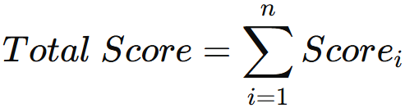  
**E. Adaptive Recommendation**  
Let $P$ be the probability of a successful job match, given user skill vector $S_{u}$ and job requirement vector $S_{j}$:

Simple matching function:

$$P(match)=\frac{∣S_{u}∩S_{j}∣}{∣S_{j}∣}$$

If weights or relevance scores are used:

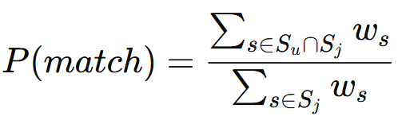

where $w_{s}$ is the weight for skill $s$.

**F. Platform Efficiency and User Engagement**  
Quiz completion rate:

$$R_{c}=\frac{\text{Number of quizzes completed}}{\text{Number of quizzes started}}$$

Average match improvement:

$$I=\frac{P_{new}-P_{base}}{P_{base}}$$

where $P_{new}$ and $P_{base}$ are post- and pre-intervention match probabilities.

These equations cover storage, generation, evaluation, plagiarism detection, and matchmaking. Empirical values like query latency or similarity threshold can be added once the platform is live.

**V.** **PERFORMANCE ANALYSIS**

The neurobridge platform performs well in supporting neurodivergent users while managing multiple candidates effectively. Its gamified quizzes and interactive dashboards make skill assessments engaging and straightforward. The platform is designed with accessibility in mind, using calm colours, dyslexia-friendly fonts, text-to-speech options, and sensory-friendly features to meet various needs. Each candidate has a personalised profile to track progress and automatically generate updated resumes. Managers can monitor multiple candidates in real time, filter by skills, viewdetailed reports, and export data easily. Neurobridge allows many users to log in at the same time across different devices without issues. By connecting skill verification with job opportunities, the platform gives employers valuable insights while streamlining the process for neurodivergent users. Overall, it balances being user-friendly, accessible, and manageable for supervisors, showing strong results in both engagement and functionality.

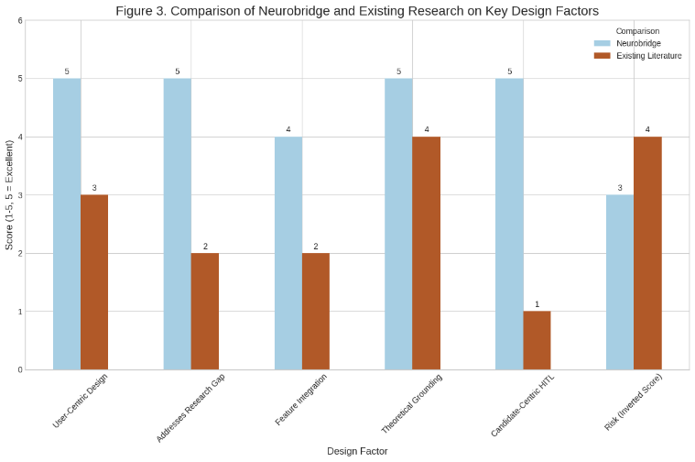

**Figure 7. Neurobridge vs Existing**

Neurobridge Vs Existing From (Figure 7), it is clear that neurobridge outperforms existing approaches across six key design factors, each rated on a scale of 1 to 5. Neurobridge scores a perfect 5 in user-focused design, addressing research gaps, theoretical grounding, and candidate-centred human-in-the-loop (HITL) features. In contrast, existing literature falls short, especially in addressing research gaps and feature integration (both scoring 2) and HITL (scoring 1). Even in areas where both perform well, like theoretical grounding, Neurobridge has a slight advantage. Importantly, it is also seen as lower risk. Overall, the graph highlights neurobridge as a stronger, more effective solution compared to previous approaches.

**VI. RESULT**

The platform helped neurodivergent users explore their skills in an engaging way. By participating in quizzes, users received feedback on their strengths and areas where they might need more support. Many users reported feeling more confident in their abilities and better prepared to apply for jobs. Employers who reviewed the suggestions found the data useful in understanding the unique needs of neurodivergent candidates and how they can improve their platforms to be more inclusive.

**VII. LIMITATIONS**

While Neurobridge offers helpful tools for neurodivergent individuals, it has several limitations. The platform relies on users’ willingness to engage and share information, which may vary. It may not meet the specific needs of every individual, and reaching users in areas with limited offline support can be difficult. Additionally, employers may not always implement suggested changes, and some users might have privacy concerns. Access to technology and professional mental health support can also be barriers for some users. Despite these challenges, the platform remains a valuable step toward more inclusive career support.

**VIII. FUTURE SCOPE**

In the future, NeuroBridge aims to become a more inclusive and supportive platform for neurodivergent individuals. It could introduce new assessments to understand individual skills and strengths. By connecting with additional job platforms, users would gain access to a wider range of opportunities that match their abilities and interests. Collaborations with schools, colleges, and mental health organisations could make the system more holistic by combining career guidance with emotional and educational support. Using advanced AI technology, NeuroBridge could deliver personalised insights, helping users track their growth and discover career paths that fit their goals. Overall, it envisions becoming a one-stop platform that empowers neurodivergent individuals to build confidence, grow continuously, and find meaningful employment..

**References**

[1] Tomczak, M. T., & Ziemiański, P. (2023). Autistic employees’ technology-based workplace accommodation preferences survey—Preliminary findings. *International Journal of Environmental Research and Public Health, 20*(10), 5773. <https://www.mdpi.com/1660-4601/20/10/5773>

[2] Menezes, N. da S., da Rocha, T. Á., Camelo, L. S. S., & Mota, M. P. (2025). “I felt pressured to give 100% all the time”: How are neurodivergent professionals being included in software development teams? In *Proceedings of the 2025 CHI Conference on Human Factors in Computing Systems* (Vol. 73, pp. 1–11). ACM. <https://dl.acm.org/doi/10.1145/3613904.3642197>

[3] Hall, K., Arora, P., Lowy, R., Kim, J. G., Mcdonald, K. M., & Mankoff, J. (2024). Designing for strengths: Opportunities to support neurodiversity in the workplace. In *Proceedings of the 2024 CHI Conference on Human Factors in Computing Systems* (Vol. 73, pp. 1–11). ACM. <https://dl.acm.org/doi/10.1145/3613904.3642424>

[4] Heggo, I., & Abdelbaki, N. (2018). Hybrid information filtering engine for personalized job recommender system. In *Advances in Intelligent Systems and Computing* (Vol. 746, pp. 553–563). Springer. <https://link.springer.com/chapter/10.1007/978-3-319-74690-6_54>

[5] Hong, S. R., Zampieri, M., Hand, B. N., Motti, V., Chung, D., & Uzuner, O. (2024). Collaborative design for job-seekers with autism: A conceptual framework for future research. *arXiv*. <https://arxiv.org/abs/2405.06078>

[6] Harris, C. G. (2018). Making better job hiring decisions using “human in the loop” techniques. In *Proceedings of the 2nd International Workshop on Augmenting Intelligence with Humans-in-the-Loop co-located with 17th International Semantic Web Conference (ISWC 2018)* (Vol. 2169, pp. 16–26). CEUR-WS. <https://ceur-ws.org/Vol-2169/paper-03.pdf>

[7] Ara, Z., Ganguly, A., Peppard, D., & Hong, S. R. (2024). Collaborative job seeking for people with autism: Challenges and design opportunities. In *Proceedings of the 2024 CHI Conference on Human Factors in Computing Systems* (Vol. 73, p. 73). ACM. <https://dl.acm.org/doi/10.1145/3613904.3642197>

[8] Saleh, J., et al. (2025). Neurodivergence and the workplace: A systematic review of the literature. *Journal of Vocational Behavior, 145*, 104666. <https://journals.sagepub.com/doi/10.1177/10522263251337564>

[9] Nair, V. S. (2025). Mapping the lacunae between neurodivergent individuals and work organizations. *Human Resource Management Review, 35*, 100857. <https://www.sciencedirect.com/science/article/pii/S0001691825004469>

[10] Johnson, S. P., et al. (2023). Understanding the experience of neurodivergent workers in image and text data annotation. *Data Science Journal, 22*, 1–14. <https://datascience.codata.org/articles/10.5334/dsj-2023-040>

[11] Memarian, B., et al. (2024). Human-in-the-loop in artificial intelligence in education: A review and entity-relationship analysis. *Computers and Education, 168*, 104201. <https://www.sciencedirect.com/science/article/pii/S2949882124000136>

[12] Kapp, E. E., Byers, S. M., Lawson, L. L., & Ougrin, C. F. (2023). Exploring neurodiversity in the workplace: Perspectives on inclusion, accommodations, and employment outcomes. *Journal of Vocational Rehabilitation, 58*, 73–89. <https://journals.sagepub.com/doi/full/10.1177/10464964231213564>

[13] van Rijswijk, J., Curșeu, P. L., & van Oortmerssen, L. A. (2024). *Cognitive and neurodiversity in groups: A systemic and integrative review.* *Small Group Research, 55*(1), 44–88. <https://journals.sagepub.com/doi/pdf/10.1177/10464964231213564>

[14] Davies, J., et al. (2024). *Career progression for autistic people: A scoping review.* *Autism in Adulthood, 6*(1), 3–14. <https://pmc.ncbi.nlm.nih.gov/articles/PMC11494842/pdf/10.1177_13623613241236110.pdf>

[15] Weber, C., Krieger, B., Häne, E., Yarker, J., & McDowall, A. (2024). *Physical workplace adjustments to support neurodivergent workers: A systematic review.* *Applied Psychology: An International Review, 73*(1), 154–192. <https://iaap-journals.onlinelibrary.wiley.com/doi/epdf/10.1111/apps.12431>

[16] Zhou, K., Alam, B., Fatemi, A. B., Howe, A., Chattu, V. K., & Nowrouzi Kia, B. (2023). *Autism spectrum disorder in the workplace: A position paper to support an inclusive and neurodivergent approach to work participation and engagement.* *Archives of Public Health, 81*(1), 199. <https://link.springer.com/article/10.1007/s44202-024-00150-5>

[17] Iannone, A., & Giansanti, D. (2023). *Breaking barriers—The intersection of AI and assistive technology in autism care: A narrative review.* *Journal of Personalized Medicine, 14*(1), 41. <https://pmc.ncbi.nlm.nih.gov/articles/PMC10817661/>

[18] Griffiths, A. J., Torres, R., Delgado, R., Hurley-Hanson, A. E., Giannantonio, C. M., Walrod, W., Maupin, Z., & Brady, J. (2024). *Understanding unique employability skill sets of autistic individuals: A systematic review.* *Journal of Employment Counseling, 61*(4), 320–350. <https://onlinelibrary.wiley.com/doi/epdf/10.1002/joec.12223>

[19] Shen, Z., & Yu, C.-L. (2025). *How technology advances research and practice in autism spectrum disorder: A narrative review on early detection, subtype stratification, and intervention.* *Brain Sciences, 15*(8), 890. <https://pmc.ncbi.nlm.nih.gov/articles/PMC12384708/>

[20] Guastella, A. J., Hankin, L., Stratton, E., Glozier, N., Pellicano, E., & Gibbs, V. (2025). *Improving accessibility for work opportunities for adults with autism in an end-to-end supported workplace program: Protocol for a mixed methods cohort study.* *JMIR Research Protocols, 14*, e60806. <https://pmc.ncbi.nlm.nih.gov/articles/PMC12082053/>

[21] Zhou, K., Richard, C., Zhai, Y., Li, D., & Fry, H. (2025). *Employment-related assistive technology needs in autistic adults: A mixed-methods study.* *European Journal of Investigation in Health, Psychology and Education, 15*(9), 170. <https://www.mdpi.com/2254-9625/15/9/170>

[22] Wall, J. (2025). *Disability technology.* *The Royal Society Report* (June 25, 2025). <https://www.techuk.org/resource/inclusive-innovation-unlocking-the-potential-of-tech-for-accessibility.html>

[23] Halpi, M. (2024). *How assistive technology works for people with autism.* *Recite Me.* <https://reciteme.com/news/assistive-technology-for-autism/>

[24] Frank, H. E., Kagan, E. R., Storch, E. A., Wood, J. J., Kerns, C., Lewin, A. B., Small, B. J., & Kendall, P. C. (2020). *Accommodation of anxiety in youth with autism spectrum disorder: Results from the TAASD study.* *Journal of Clinical Child & Adolescent Psychology, 51*(2), 219–229. <https://pmc.ncbi.nlm.nih.gov/articles/PMC7722072/>

[25] Katirai, A. (2025). *Autism and emotion recognition technologies in the workplace.* *Autism, 29*(3), 554–565. <https://pubmed.ncbi.nlm.nih.gov/39282995/>

[26] Bae, S., Hong, J., Ha, S., Moon, J., Yu,Lee, D., Yoo, H., Lee, Y., Son, J.-W., & Cheon, K.-A. (2025). *Multimodal AI for risk stratification in autism spectrum disorder: integrating voice and screening tools.* *npj Digital Medicine, 8*, 538. <https://www.nature.com/articles/s41746-025-01914-6>

[27] Walsh, E., Holloway, J., McCoy, A., & Lydon, H. (2017). Technology-aided interventions for employment skills in adults with autism spectrum disorder: A systematic review. *Review Journal of Autism and Developmental Disorders*, 4, 12–25. [https://link.springer.com/article/10.1007/s40489-016-0093-x](https://link.springer.com/article/10.1007/s40489-016-0093-x?utm_source=chatgpt.com)